BÁO CÁO THỰC HÀNH LAB 01  
LẬP TRÌNH HƯỚNG ĐỐI TƯỢNG

# 2. First Programs

## Very first Java Program

### Write, compile the first Java application:

Bài code 1:

* Kết quả:

Bài code 2:

* Kết quả:



Bài code 3:

* Kết quả:

### Write, compile the first dialog Java program

* Kết quả:

### Write, compile the first input dialog Java application

* Kết quả:

### Write, compile, and run the following example:

* Kết quả:

### Write a program to calculate sum, difference, product, and quotient of 2 double numbers which are entered by users.

**Notes**

* To convert from String to double, you can use

**double num1 = Double.parseDouble(strNum1)**

* Check the divisor of the division

* Kết quả:

### Write a program to solve:

*For simplicity, we only consider the real roots of the equations in this task.*

* **The first-degree equation (linear equation) with one variable**

**Note**: A first-degree equation with one variable can have a form such as $ax+b=0 \left(a≠0\right)$.

You should handle the case where the user input value 0 for a.

* **The system of first-degree equations (linear system) with two variables**

**Note**: A system of first-degree equations with two variables $x_{1}$ and $x_{2}$ can be written as follows.

$$a_{11}x_{1}+a_{12}x_{2}=b_{1}$$

$$a_{21}x_{1}+a_{22}x_{2}=b_{2}$$

You should handle the case where the values of the coefficients produce infinitely many solutions and the case where they produce no solution.

**Hint**:

Use the following determinants:

$$D=\left|a_{11} a_{12} a_{21} a_{22} \right|=a_{11}a_{22}-a_{21}a_{12}D_{1}=\left|b_{1} a_{12} b_{2} a_{22} \right|=b_{1}a_{22}-b_{2}a_{12}D_{2}=\left|a_{11} b_{1} a_{21} b_{2} \right|=a_{11}b_{2}-a_{21}b_{1}$$

* **The second-degree equation with one variable**

**Note**: A second-degree equation with one variable (i.e., quadratic equation) can have a form such as $ax^{2}+bx+c=0$, where x is the variable, and a, b, and c are coefficients ($a≠0$).

You should handle the case where the values of the coefficients produce a double root & the case where they produce no root. You should also handle the case where the user input value 0 for a.

**Hint**:

Use the discriminant

* Kết quả:

# 6. Exercises

## 6.1. Write, compile and run the ChoosingOption program:

* Kết quả:

## 6.2. Write a program for input/output from keyboard

* Kết quả:

## 6.3. Write a program to display a triangle with a height of n stars (*), n is entered by users.

**E.g. n=5:**

*

***

*****

********

***********

**Note**: You must create a new Java project for this exercise.

- Kết quả:

## **6.4. Write a program to display the number of days of a month**, which is entered by users (both month and year). If it is an invalid month/year, ask the user to enter again.

**Note**: You must create a new Java project for this exercise.

* The user can either enter a month in its full name, abbreviation, in 3 letters, or in number. To illustrate, the valid inputs of *January* are January, Jan., Jan, and 1.
* The user must enter a year in a non-negative number and enter all the digits. For instance, the valid inputs of year *1999* is only 1999, but not 99, “one thousand nine hundred ninety-nine”, or anything else.
* A year is either a common year of 365 days or a leap year of 366 days. Every year that is divisible by 4 is a leap year, except for years that are divisible by 100, but not by 400. For instance, year 1800 is not a leap year, yet year 2000 is a leap year. In a year, there are twelve months, which are listed in order as follows.

|  |  |  |  |  |  |  |  |  |  |  |  |  |
| --- | --- | --- | --- | --- | --- | --- | --- | --- | --- | --- | --- | --- |
| **Month** | January | February | March | April | May | June | July | August | September | October | November | December |
| Abbreviation | Jan. | Feb. | Mar. | Apr. | May | June | July | Aug. | Sept. | Oct. | Nov. | Dec. |
| **In 3 letters** | Jan | Feb | Mar | Apr | May | Jun | Jul | Aug | Sep | Oct | Nov | Dec |
| In Number | 1 | 2 | 3 | 4 | 5 | 6 | 7 | 8 | 9 | 10 | 11 | 12 |
| **Days of Month in Common Year** | 31 | 28 | 31 | 30 | 31 | 30 | 31 | 31 | 30 | 31 | 30 | 31 |
| Days of Month in Leap Year | 31 | **29** | 31 | 30 | 31 | 30 | 31 | 31 | 30 | 31 | 30 | 31 |

* Kết quả:

## 6.5. Write a Java program to sort a numeric array, and calculate the sum and average value of array elements.

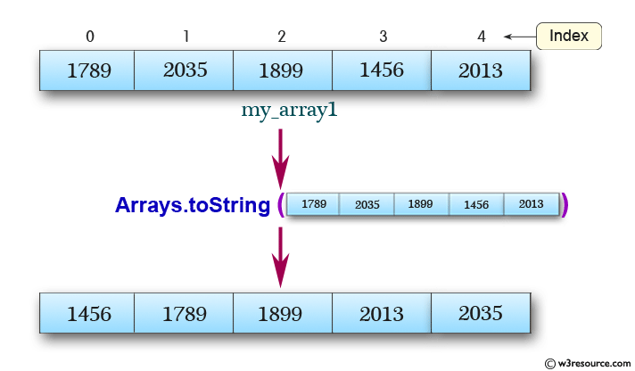

**Note**: You must create a new Java project for this exercise.

- The array can be entered by the user or a constant.

* Kết quả:

## 6.6. Write a Java program to add two matrices of the same size.

**Note**: You must create a new Java project for this exercise.

- The matrices can be entered by the user or constants.

* Kết quả:

